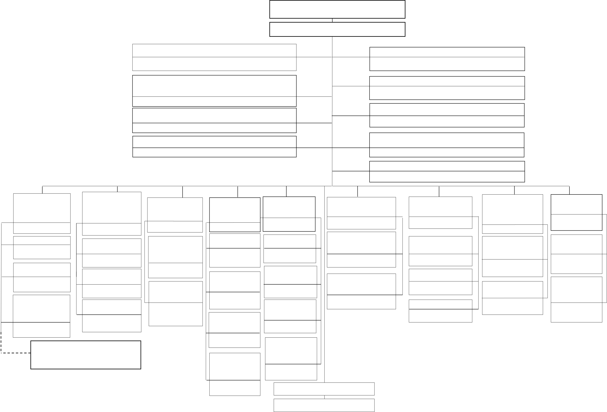

***Chart II* THE APPROVED ORGANISATION STRUCTURE OF LOCAL GOVERNMENT AUTHORITIES**   
**(*Approved by the President on 29th January, 2022*)**

**COUNCIL**

**DIRECTOR**

|  |  |
| --- | --- |
| **WASTE MANAGEMENT AND SANITATION UNIT**  HEAD  **NATURAL RESOURCE AND ENVIRONMENTAL CONSERVATION UNIT**  HEAD  **SPORTS, CULTURE AND ARTS UNIT**  **HEAD**  **FINANCE AND ACCOUNTS UNIT**  HEAD | **LEGAL SERVICES UNIT**  HEAD  **INTERNAL AUDIT UNIT**  HEAD  **PROCUREMENT MANAGEMENT UNIT**  HEAD  **ICT UNIT**  HEAD |

**GOVERNMENT COMUNICATION UNIT**   
HEAD

|  |  |  |  |  |  |  |  |  |  |
| --- | --- | --- | --- | --- | --- | --- | --- | --- | --- |
| **INFRASTRUCTURE, RURAL AND**  **URBAN**  **DEVELOPMENT**  **DIVISION**  HEAD | **HEALTH, SOCIAL**  **WELFARE AND**  **NUTRITION**  **SERVICES DIVISION**  HEAD | **INDUSTRY, TRADE AND INVESTMENT DIVISION** | **PRE- PRIMARY AND PRIMARY EDUCATION**  **DIVISION**  HEAD | **SECONDARY EDUCATION DIVISION** | **COMMUNITY**  **DEVELOPMENT**  **DIVISION** | | **AGRICULTURE,**  **LIVESTOCK AND**  **FISHERIES DIVISION** | **ADMINISTRATION AND HUMAN**  **RESOURCE**  **MANAGEMENT**  **DIVISION**  HEAD | **PLANNING AND**  **COORDINATION DIVISION**  HEAD |
| HEAD | HEAD | | HEAD |
| HEAD |
| **WORKS SECTION**  OFFICER IN  CHARGE **3** | **HEALTH SERVICES SECTION**  OFFICER IN  CHARGE | **INDUSTRY**  **DEVELOPMENT**  **AND INVESTMENT SECTION** | **ACADEMIC**  **SECTION** | **ACADEMIC SECTION**  OFFICER IN CHARGE | **CROSS CUTTING**  **ISSUES COORDINATION SECTION**  OFFICER IN CHARGE | | **AGRICULTURE**  **SECTION** | **HUMAN RESOURCE MANAGEMENT**  **SECTION** | **PLANNING AND** HEAD OF UNIT **BUDGETING**  **SECTION** |
| OFFICER IN CHARGE | OFFICER IN CHARGE |
| OFFICER IN CHARGE |
| OFFICER IN  CHARGE | STATISTICS AND LOGISTICS  SECTION  OFFICER IN  CHARGE | | **NGOs AND CBOs COORDINATION SECTION** | **LIVESTOCK SECTION** | OFFICER IN CHARGE |
| ROADS  SECTION  OFFICER IN CHARGE | **SOCIAL WELFARE SECTION**  OFFICER IN  CHARGE |
| **STATISTICS**  **AND LOGISTICS SECTION** |
| **TRADE AND**  **MARKETING**  **SECTION** | OFFICER IN CHARGE | **ADMINISTRATION SECTION** | **MONITORING AND**  **EVALUATION SECTION** |
| **RURAL AND**  **URBAN**  **DEVELOPMENT SECTION**  OFFICER IN CHARGE | **NUTRITION**  **SERVICES SECTION**  OFFICER IN  CHARGE | OFFICER IN CHARGE | SPECIAL NEEDS | OFFICER IN CHARGE | | **FISHERIES SECTION** | OFFICER IN CHARGE |
| OFFICER IN  CHARGE | OFFICER IN CHARGE |
| **SPECIAL NEEDS** | EDUCATION | | |
| OFFICER IN CHARGE |
| SECTION | | |
| **EDUCATION** | OFFICER IN | | |
| **SECTION** | CHARGE | | |
| OFFICER IN CHARGE | ADULT AND | | |
| **LGA’S LAND ADMINISTRATION OFFICE –** | |
| **ADULT AND** | NON-FORMAL | | |
| **MINISTRY OF LAND, HOUSING AND** | |
| EDUCATION | | |
| **HUMAN SETTLEMENTS** | |
| SECTION | | |
| **NON-FORMAL** |
| OFFICER IN | | |
| **EDUCATION** |
| CHARGE | | |
| **SECTION** |
| OFFICER IN | **WARD EXECUTIVE OFFICE** 11 | | |
| CHARGE |

**VILLAGE/MTAA EXECUTIVE OFFICE**